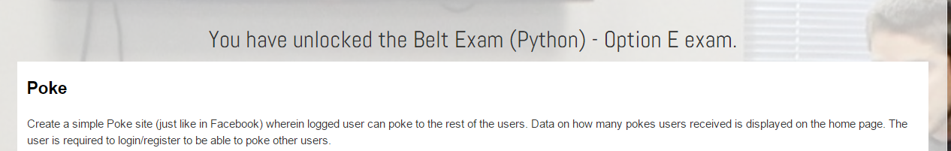

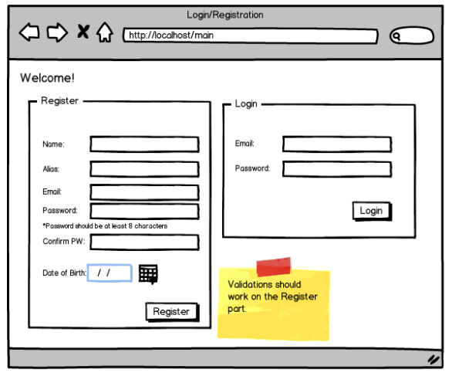

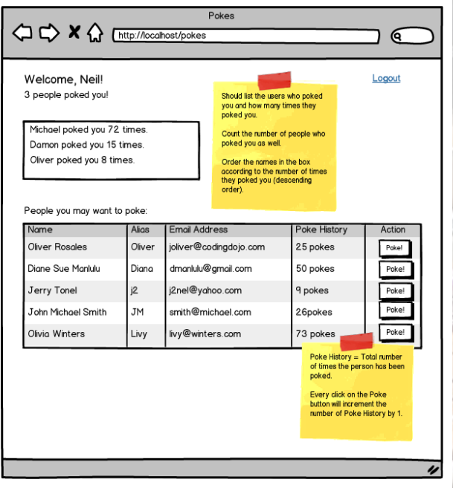

**Features Required:**

1. Login and Registration with necessary validations. Validation errors should appear on the page.
2. All user information should be from the database. Have at least 10 sample data.
3. Name of the logged user should not be included on the list of people logged user may poke.
4. Poke history should be updating upon clicking the Poke button.
5. Number of pokes and data on who poked the logged user should be updating.
6. Logout feature should be working.
7. You must be able to deploy your work to Amazon EC2 and provide the IP address or subdomain/domain name to where your work has been deployed. Please note that Heroku deployment is not honored.

**Submission Requirement:**Your code, exported database file, a text file with the IP address or subdomain/domain name for the deployed work and short video demo link.